

Congratulations & Welcome to our 2015 Fellows!

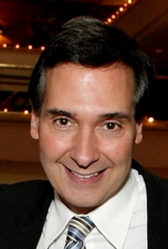
Alan N. Barkun, McGill University
Professor of Medicine and DG Kinnear Chair in Gastroenterology. Director, Digestive Endoscopy; Chief Quality Officer of the Division of Gastroenterology, McGill University Health Centre; and Clinical lead, Quebec colorectal cancer screening program. Recipient of national and international awards, he has published over 600 peer-reviewed articles and abstracts and given over 600 international presentations on emerging and established digestive endoscopic technologies with emphasis on methodological, clinical and cost-effectiveness trials of treatments for upper gastrointestinal bleeding (UGIB), bilio-pancreatic diseases and colorectal cancer screening.

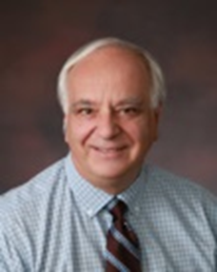
Robert Bortolussi, Dalhousie University
Pioneer pediatric infectious disease specialist. In 1982 he responded to a major outbreak of listeriosis in Nova Scotia by discovering the responses of infants to listeria and developing models for studying this and other diseases. His international reputation in listeriosis continues today. He has been a mentor and supporter of clinician scientists in Canada and internationally through his Handbook for Clinician Scientists and the Canadian Child Health Clinician Scientist program. His passion for global health led him to cofound "Micro Research" where clinician scientists in developing countries are supported to address local health challenges.

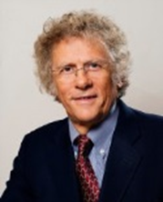
Nick Busing, University of Ottawa
Visionary change agent, consensus-builder, and internationally recognized authority on medical education and physician resource planning. Led transformative change from 2005-2013 as President and CEO of the Association of Faculties of Medicine of Canada; positioned AFMC as the lead organization for medical education and research in Canada, and become 'the face of Canadian academic medicine' nationally and internationally. During his tenure, Nick conceived The Future of Medical Education in Canada project (FMEC) leading to undergraduate and postgraduate reports, recognized internationally as seminal documents..

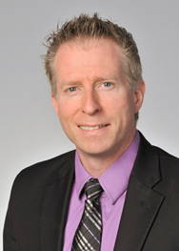
André C Carpentier, Université de Sherbrooke
Professor of medicine and CIHR‐GSK Chair in Diabetes. Founding Director of the FRQS Research Network in Cardiometabolic Health, Diabetes and Obesity. An internationally acclaimed integrative physiologist and expert in lipid and carbohydrate metabolism, he has developed original methods and protocols to measure organ‐specific dietary fatty acid and brown adipose tissue oxidative metabolism applicable in animals and in humans. He published over 100 peer‐reviewed manuscripts, gave over 100 invited lectures, and received 30 awards, including the 2012 CDA‐CIHR Young Investigator Award.


Angela Colantonio, University of Toronto
Lead of an internationally recognized research program on outcomes of persons with neurological disability, with a focus on long-term traumatic brain injury of over 20 years. Achievements include leading over 60 research grants from the most prestigious international funding sources, 2 research chairs and over 200 publications. She has received numerous awards, national and international distinctions. Fellow, American Congress of Rehabilitation Medicine and American College of Epidemiology. She has mentored over 65 graduate students who have taken leadership roles in academic, health care, and industry sector settings.

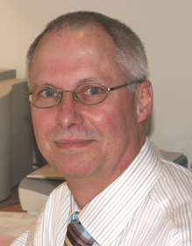
James Ronald Davie, University of Manitoba
Recognized leader in chromatin, a rapidly expanding field now known as epigenetics. His several seminal findings resulted in knowledge translation towards improving human health. His early studies set the foundation for development of histone deacetylase inhibitor drugs, which are approved therapeutics for hematologic malignancies and in clinical trials for a broad range of human disorders. His studies continue to significantly advance epigenetic knowledge synthesis.


Barbara L. Davies, University of Ottawa
Vice Dean-Research at the Faculty of Health Sciences and Founder of an innovative Nursing Best Practice Research Centre. Her awards include: the Sigma Theta Tau International Honor Society of Nursing Practice/Academe Innovative Collaborative award; Health Services Research Career Scientist; Ontario Premier’s Research Excellence; and Distinguished Alumni University of Toronto. Her internationally recognized leadership and research has brought research results into health services to improve health care delivery and patient outcomes. Notably, she has built widely-used sustainability and spread models and tools to promote evidence-based health care.

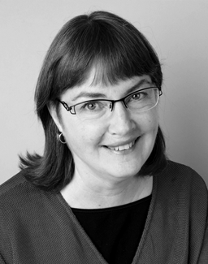
Dana V. Devine, University of British Columbia
Chief Medical & Scientific Officer of Canadian Blood Services and UBC Professor in the Centre for Blood Research, roles through which she provides critical scientific leadership to Canada’s blood system. Internationally recognized for her impact on the field of blood transfusion through both research and mentorship. Her innovative efforts to improve blood product quality have shifted our approach to transfusion products. Her work to establish new structures to foster transfusion science in Canada has helped to create a renewed transfusion research community.

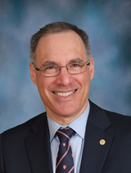
David H. Eidelman, McGill University
Dean and Vice Principal, Health Affairs; former Chair of Medicine and Physician-in-Chief of the MUHC; and President of the Canadian Association of Chairs of Medicine. Current leadership roles were preceded by a productive period of research in pulmonary morphology and lung mechanics in inflammatory disease, especially emphysema and asthma. His laboratory elaborated a lung explant model and exploited a rate model of asthma. He has a keen interest in medical education and participated in the development and implementation of a new curriculum at his Faculty.

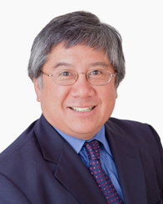
Geoffrey T. Fong, University of Waterloo
Founder and Chief Principal Investigator of the International Tobacco Control Policy Evaluation Project (ITC Project)’ first-ever international cohort study of tobacco use and the first/only international research study evaluating the impact of the WHO Framework Convention on Tobacco Control (FCTC) policies. Dr. Fong was awarded the WHO World No Tobacco Day Award in 2013 in recognition of his work which has been instrumental in the advancement of FCTC implementation worldwide. Dr. Fong will receive the Luther R. Terry Award for Outstanding Research Contribution at the upcoming World Conference on Tobacco or Health, 2015.

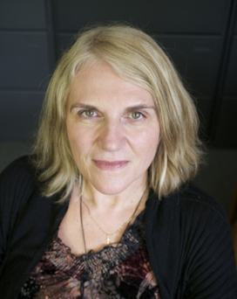
Cheryl Forchuk, Western University
Her leadership has been recognized with a Distinguished University Professor Award. She has published on many topics including transitional discharge, therapeutic relationships, technology in mental health care and housing/homelessness. Her research explores systems issues related to mental health care including: implementation of the transitional discharge model, housing/homeless ness, poverty, community integration and the use of technology in mental health care. Projects start with the voice of consumers/providers to envision a better way of providing services, then implement new strategies to enact such visions and evaluate strategies including testing across multiple sites.


Lise Gauvin, University of Montreal
A leader in the study of physical activity promotion and prevention of eating disorders for over 25 years. One of the inaugural CIHR Applied Public Health Chairs, she pioneered the scientific use of innovative quantitative methodologies to study the reach, acceptability and outcomes of population level interventions including public bicycle share programs, inter-sectorial collaboration to promote healthy and diversified body image and grassroots initiatives to render built environments more sustainable. She co-presided the writing team that developed the Toronto Charter for Physical Activity, a healthy public policy tool now available in 21 languages.


Laurie N. Gottlieb, McGill University
Pioneer in academic nursing in Canada. She was a key player in the development of the McGill Model of Nursing, now widely used worldwide, and has further developed that into practice and training of nurses and other health care professionals. Editor for over two decades of the Canadian Journal of Nursing Research, she has brought nursing leaders from across Canada together through the journal. With numerous invitations as a visiting professor she is recognized internationally as a leader in health care.

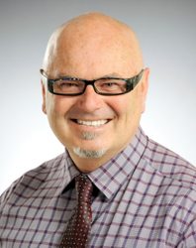
david Michael Gregory, University of Regina
Dean, Faculty of Nursing and recognized expert on the social and cultural determinants of health, particularly in Aboriginal communities. Prolific scholar, educator and clinician, he is one of Canada’s foremost leaders in nursing education, having played instrumental roles in the development of Faculties of Nursing in Manitoba and Saskatchewan, establishing innovative community education programs and effective partnerships among post-secondary institutions. His research focuses on Aboriginal health and education, qualitative research methodologies, men in nursing and medical anthropology.

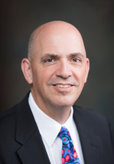
Robert S. Hogg, Simon Fraser University
One of Canada’s leading HIV/AIDS researchers and Director of the Drug Treatment Program of the BC Centre for Excellence in HIV/AIDS. His research has informed Governments, enhanced best practice guidelines and provided essential evidence for groundbreaking policies including the expansion of anti-retroviral therapy in BC and elsewhere. His work provided the first global scientific evidence that HIV can be a long term chronic condition rather than a fatal disease in high income countries. This paradigm shift has reduced the fear and stigma surrounding the disease in both HIV positive persons and in the societies in which they live.


Susan B. Jaglal, University of Toronto
Research interests include osteoporosis and hip fractures, rare neurological conditions, and rehabilitation health services with emphasis on utilization, appropriateness, effectiveness of services and knowledge transfer. In 2005 she was awarded the Toronto Rehabilitation Institute Chair at the University of Toronto (renewed three consecutive terms) to advance rehabilitation health services research. Published over 160 peer-reviewed papers, obtained over $6 million in grant funding and mentored numerous graduate students and junior scientists. The findings of her research have been used by policy makers. She is Past-President of the Canadian Society for Epidemiology and Biostatistics.

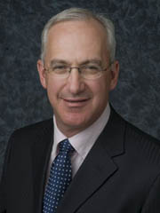
Laurence H. Klotz, University of Toronto
Professor of Surgery and Chair, Canadian Urology Research Consortium and World Urologic Oncology Federation (WUOF). Member, American Association of Genito-Urinary Surgeons; past President, Urological Research Society and Canadian Urological Association; Honorary Member of the American, Chinese, and Chilean Urological Associations. Research includes molecular and metabolic effects of androgens and androgen deprivation therapy (ADT), active surveillance, focal therapy for low risk disease using HIFU, and prostate cancer prevention. Associate Editor of the Journal of Urology; Editor Emeritus of the Canadian Urology Association Journal.

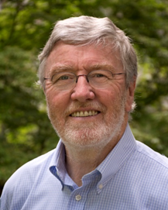
Michael I MacEntee, University of British Columbia
Professor of Prosthodontics and Dental Geriatrics. A teacher, researcher and clinician focused on quality of life and access to care for older people. He has published numerous books, chapters, and peer-reviewed papers on the measurement, distribution, impact, and management of mouth-related disorders. He is a Past President of both the Royal College of Dentists of Canada and the International College of Prosthodontists. In 2009, he received a Distinguished Scientist Award from the International Association for Dental Research and a Killam Teaching Prize. Currently, he is the editor-in-chief of Gerodontology.

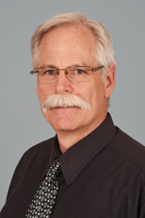
Stuart McGill, University of Waterloo
A guiding leader in the rehabilitation of low back pain through the translation of his novel spine injury research into knowledge for health science practitioners. His textbooks and educational workshops inform clinical practice and influence policy targeting the assessment and treatment of low back pain. He was key in the creation of Kinesiology as a regulated health profession and the formation of a regulatory College of Kinesiologists in Ontario. He is a recipient of the International Society for the Study of the Lumbar Spine Award and the Canadian Society for Biomechanics Career Award.

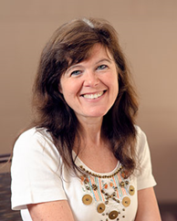
Lynn McIntyre, University of Calgary
Public health physician, former 3-term Dean and a Canadian pioneer in household food insecurity research. Contributions to the improvement and occasional transformation of a range of Government and non-Government Canadian institutions are the outcome of her ethos of service, skills in good governance and belief in the importance of civil society. Her steadfast commitment to social justice and her unrelenting pursuit of excellence have left their mark on food insecurity policy analysis. A recognized mentor to students and colleagues at all stages of career.


John R. McLaughlin, University of Toronto
Studies the causes of cancer and combines biological approaches with population based analysis. Successfully conducted large complex studies that involve investigators from multiple disciplines. Shown a remarkable ability to translate the results of this research in a form that the general public and decision makers in the health system can easily understand. Served in a number of senior leadership roles in health organizations where he has implemented complex population based programs and built new research programs.

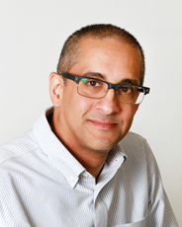
Ravi S. Menon, Western University
Pioneer in the field of functional magnetic resonance imaging (FMRI), which has become an indispensable, noninvasive tool for the study of human brain function. Early innovator in the development of technology for ultra-high field FMRI, focusing on understanding what it measures as well as the changes in anatomy and function that accompany disease and degeneration in the brain. Professor of Medical Biophysics; Director of the Centre for Functional and Metabolic Mapping at Western University; Canada Research Chair in FMRI.

Eric Meslin, Indiana University
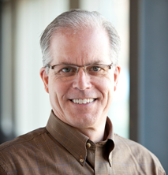
Exceptional contributions made to science policy and health research in Canada regarding ethical, legal and social issues (ELSI) of biomedical research, human genetics and genomics. Even while based in the US, his academic scholarship and senior advisory roles with Canadian funding bodies jointly contribute to a deeper understanding of ELSI issues and have positioned Canada to be a respected world leader in the ethical and policy issues in health research, stem cell science, genomic studies and global health. His expertise on research governance, guideline harmonization and ethics review are valued by domestic and international collaborators.

Marek Michalak, University of Alberta
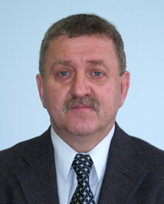
Internationally recognized authority in the fields of protein folding and calcium homeostasis and their roles in pathology of human diseases. His pioneering work on membrane-associated chaperones (proteins that assist in protein folding) and protein quality control have had a major impact on our understanding and treatment of many protein folding disorders including congenital heart diseases, Alzheimer's disease, Parkinson's disease, multiple sclerosis and prion diseases. His work provides a unique blend of discovery research with a high relevance to clinical applications and changes in a fundamental way how we view the protein quality control machinery of cellular systems.

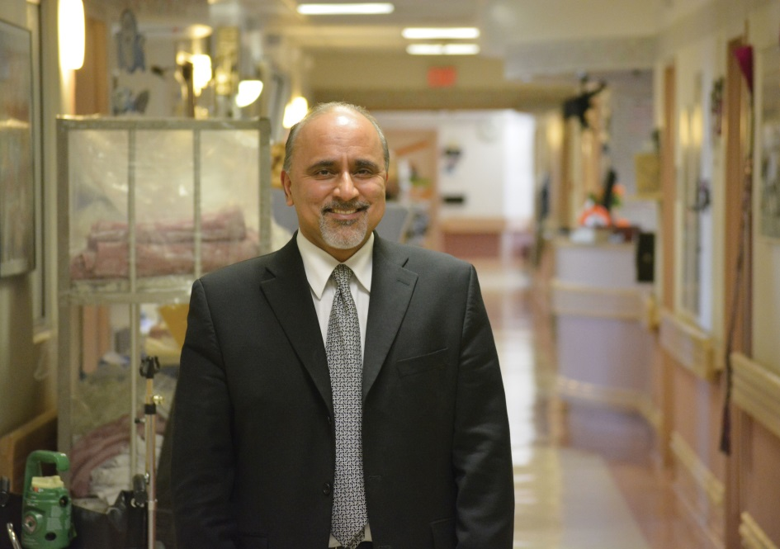
Rajiv Midha, University of Calgary
Internationally recognized surgeon, scientist and educator. He is the foremost neurosurgical expert on peripheral nerve disorders. His research has produced groundbreaking insights on the repair of peripheral nerve injury, while his clinical program provides state-of-the-art patient-centric multidisciplinary care. He has led international organizations devoted to the advancement of nerve surgery, and he is a member of the highly exclusive Academy of Neurological Surgery. He lectures extensively throughout North America and internationally and serves on the editorial board of the top two ranked neurosurgery journals.

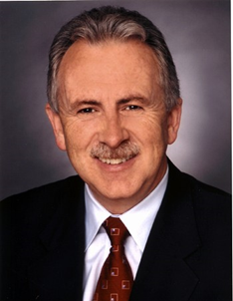
Paul M. O’Byrne, McMaster University
Chair of Medicine at the Michael G DeGroote School of Medicine. Internationally recognized for seminal contributions into understanding the causes and treatment of asthma, including the first studies of the central role of airway inflammation in its initiation and persistence. His work has explained the mechanisms of allergen-induced inflammatory responses and aided the development of anti-leukotrienes as a new asthma treatment. He has published extensively in the most highly cited peer-review journals. His studies of asthma treatment have influenced treatment guidelines worldwide.

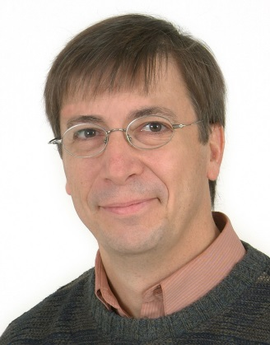
François Rousseau, Universite Laval
Le Dr Rousseau est un médecin de laboratoire et chercheur subventionné depuis plus de 25 ans dans le domaine de la génétique humaine, de la recherche sur les services de santé et du transfert technologique. Il a orienté sa carrière vers la production de données probantes afin d’aider les décideurs à identifier les services de santé permettant l’amélioration de la santé des Canadiens et Canadiennes. Il sert de plus la qualité des soins au Canada en siégeant comme expert sur plusieurs comités d’experts en santé. C’est un leader reconnu dans le domaine de la recherche et l’évaluation des technologies diagnostiques.

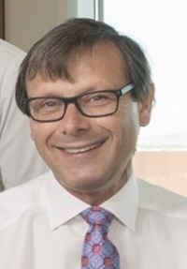
Andrew Mark James Shapiro, University of Alberta
Invigorated the field of islet transplantation by leading the team that developed the Edmonton Protocol, an islet transplantation technique considered worldwide as a major advancement for managing severe Type 1 diabetes. He continues his translational research, managing the largest islet transplant program in the world. His work has provided insight into, and furthered our understanding of, immune tolerance. Current efforts include leading Canada-wide research to improve organ procurement through emerging ex vivo perfusion technology. This technology holds the promise of significantly improving the rate of organ utilization and graft function.

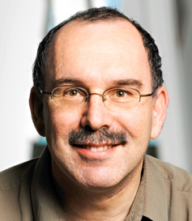
Keith A. Sharkey, University of Calgary
Pioneered fundamental and translational discoveries in the neural control of the gastrointestinal tract in health and disease. His innovative research has provided significant insights into the etiology and treatment of inflammatory bowel disease (IBD). Expert in the endocannabinoid system of the gut, he has used his knowledge of cannabinoid biology to advise Health Canada. A tireless community volunteer as Crohn's and Colitis Canada Chair in IBD Research. For his international leadership, editorial abilities and commitment to advance gastrointestinal health, he has been recognized with numerous national and international awards.


Jean A. Shoveller, University of British Columbia
Outstanding public health scholar whose leadership and vision has contributed to system change nationally and internationally. Founding member of UBC’s School of Population and Public Health, she led the Social and Life Course Theme and served on the Senior Executive Committee. As the Centre Director at UBC’s Human Early Learning Partnership and the Co-Chair of Population Health Intervention Research Initiative for Canada she fostered new understandings of the social determinants of health. Founder of the UBC Youth Sexual Health Team.


Katherine Anne Siminovitch, University of Toronto
Discoveries of genetic and molecular pathways underpinning immunologic disease have elucidated new paradigms of signal transduction and cell biology, her work illuminating the central roles for inhibitory and cytoskeletal signalling effectors in regulating immunity and driving autoimmune and immune deficiency diseases. Her development and leadership of the only genetics service in Ontario dedicated exclusively to the management of adults with Mendelian genetic diseases has transformed genetics care in the province and created a unique translational platform for connecting genomics research advances to clinical application so as to expedite uptake of personalized treatment approaches into medical practice.

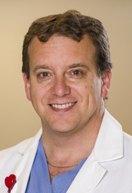
Christopher S Simpson, Queen’s University
President, Canadian Medical Association and recognized nationally as a leader in heart rhythm disease research, health policy research and medical leadership. He has made significant contributions to all of these areas. His work in medical fitness to drive is widely-cited internationally and he has led efforts in post-market safety surveillance of medical devices. As Chair of the Wait Time Alliance he led the development of national wait time benchmarks. Currently, as CMA President, he is leading the effort for a national seniors’ strategy as well guiding the profession following the Supreme Court ruling on physician-assisted suicide.

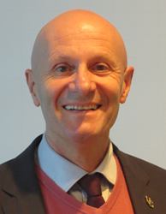
Alastair J S Summerlee, University of Guelph
Professor of Neuroendocrinology, Department of Biomedical Sciences at the Ontario Veterinary College, and former President and Vice-Chancellor of the University of Guelph (2003-2014). He earned international acclaim for his discovery of the relaxin-brain connection and the roles of the hormone relaxin in neural function, skeletal muscle blood vessels, tumour growth and metastasis. Received international awards including one for a highly effective method of reducing iron deficiency anemia in women and children in Cambodia. He is conducting research on HIV/AIDS in aboriginal populations and addressing health and humanitarian concerns in developing countries.

Colleen Marie Varcoe, University of British Columbia
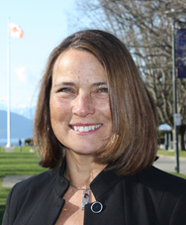
Renowned Canadian leader and advocate on women’s health promotion with an emphasis on violence against women, and the promotion of ethical, socially just health care. She has made substantial inroads in our understanding of the health consequences of violence, including health care policy and practice in response to violence. She has informed the measurement of discrimination and the advancement of the concept of cultural safety in health care in Canada. Author of over 100 publications in peer reviewed journals and books, she presents provincially, nationally and internationally to diverse research, educational and public audiences.

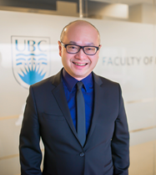
Roger Y. M. Wong, University of British Columbia
Professor of Medicine and Associate Dean, Postgraduate Medical Education. Past President, Canadian Geriatrics Society. Advanced academic health sciences related to geriatrics. Founded the Acute Care for Elders Unit in Vancouver that is now replicated internationally and was instrumental in the success of indexing the first Canadian geriatric medicine journal in PubMed. Medical education achievements (CanMEDS, quality improvement) have been recognized with UBC Killam Teaching Prize, Royal College of Physicians and Surgeons of Canada Donald Richards Wilson Award, and UBC Medicine Master Teacher Award.

Lonnie Zwaigenbaum, University of Alberta
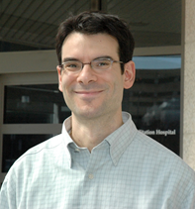
Stollery Children's Hospital Foundation Chair in Autism. Renowned for work on Autism Spectrum Disorder (ASD). For 15 years he has co-led a multi-site longitudinal study of high-risk infants to characterize early development of ASD and co-developed the first observational scale to detect signs of ASD in infants which has been adopted internationally. National ASD Project Lead with NeuroDevNet, a Network of Centres of Excellence on neurodevelopmental disabilities; Director, Canadian Autism Research Training Program.

