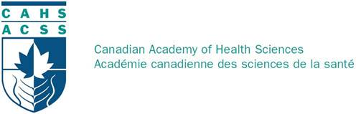

e-Blast
Visit us on the web at www.cahs-acss.ca
September 2015  Welcome to the September 2015 CAHS e-Blast, your source for updates on activities of the Canadian Academy of Health Sciences.  PRESIDENT’s MESSAGE  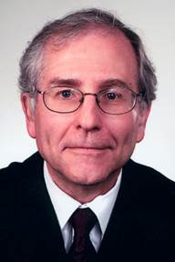  Dear CAHS Fellows,  The principal motivation for this eblast is the Syrian refugee crisis and related Middle East and Northern Africa migrations that are overwhelming near neighbours and challenging EU countries. The agonizing visual messages and stories have increasingly brought the human suffering into the forefront in our country. The implications for Canadians have been much debated and potential approaches appear more complex in the context of a Federal election campaign. The Executive of the CAHS has discussed the potential for constructive actions by the Academy.  The CAHS is not an advocacy organization, apart from our fundamental belief in the necessity for sound evidence in support of public policy of importance to the health of Canadians. Our Fellows are diverse, and are likely to pursue their wide range of advocacy positions individually and in other associations whose missions are to pursue such goals. Accordingly, the Executive Committee has wrestled with the question of “What are the appropriate roles for CAHS in the current refugee crisis?”  Amongst CAHS objectives are the following: to “Support the development of timely, informed and strategic advice on urgent health issues” and to “Represent Canadian health sciences internationally and liaise with like international academies to enhance understanding and potential collaborations on matters of mutual interest.” Accordingly, we have taken these actions:  - Peter Singer, CAHS Foreign Secretary, has contacted several large NGOs (UNICEF, CARE, World Vision, Aga Khan Foundation, Save the Children, Plan Canada) whose missions are directly relevant to the present crisis and whose capacities are substantial. He has asked for suggestions as to how CAHS might help.  - As president of CAHS, I am indicating to our fellows that the Academy is aware of the refugee crisis. I also ask for the following inputs from CAHS fellows a) if you have or will be taking any action individually or as part of a group, please send me a summary of the action and its current status as a source of information for other fellows and/or b) if you have any thoughts as to how CAHS fellows might undertake constructive actions, send them to me. I will forward all information received to the Executive Committee for discussion. John.cairns@ubc.ca  Following the Annual meeting we will again communicate with Fellows with an update on our role in this international refugee crisis.  Our Annual Meeting is almost upon us. Registration for the meeting is excellent and although all the room blocks have been taken up, accommodation is readily available elsewhere in Ottawa. Registration remains open and I hope we will see a few more Fellows register in the days leading up to the event. To Register Now Click Here  The Forum, on Thursday, September 17, entitled “The Rising Tide of Dementia in Canada: Facing the Critical Challenge by 2025” will be outstanding. Additional highlights include the Paul Armstrong Lecture by David Naylor later that evening entitled “How Canada’s Healthcare System Can Regain Lost Ground” and a special 10th Anniversary Symposium on Friday, September 18 entitled “Learned Societies – A Real Value or a Pastime for Aging Academics?” To Access the Program Click Here  I hope to see you in Ottawa.  Best wishes,  Sincerely,  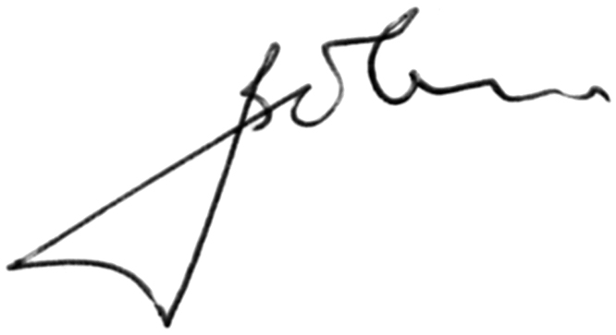  Sincerely,  John Cairns MD, FRCPC, FRCP (Lond), FCAHS, FACC |  | Secretary’s Note  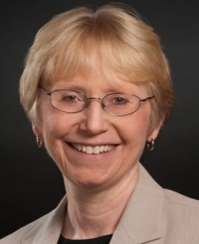  Please remember that we rely on our Fellows, to keep us abreast of their own news and that of their colleagues. We look forward to hearing from you throughout the year and to receiving photographs that we can use to promote our collective success!  Sincerely,  Sally Thorne  Sally.Thorne@nursing.ubc.ca  Contact  Canadian Academy of Health Sciences  180 Elgin Street, Suite 1403  Ottawa, Ontario  K2P 2K3  Telephone  613-567-2247  Email  info@cahs-acss.ca

