Canadian Academy of Health Sciences
Académie canadienne des sciences de la santé

CALL FOR NOMINATIONS 2013

The objective of the Canadian Academy of Health Sciences is to provide assessments of and advice on key issues relevant to the health of Canadians.

The Academy recognizes the full breadth of academic health science including all of the medical and allied health sciences and ranging from fundamental science to social science and population health. Fellows elected to the Academy will be health and biomedical science leaders who have achieved national and international peer recognition for their contributions to the health sciences (awards, invited lectures, invited reviews and editorials). They will have demonstrated leadership (roles and offices in their own institution and in regional, national and international organizations); creativity (scholarship, publications, innovative technologies, patents); distinctive competencies (identifiable national/international expertise that will contribute to the body of expertise of the CAHS); and commitment to advance academic health sciences (academic service and innovation at local, national and international levels, including teaching and public service).

Individuals are elected to the organization after a nominating and peer review procedure, which seeks to recognize those who have a demonstrated track record of academic achievement. The review places considerable emphasis on established, internationally recognized leadership and impact that have meaningfully advanced the academic health sciences. At the time of election, Fellows will normally hold the rank of Full Professor. They must be Canadian citizens or have been Canadian residents for the preceding three (3) years. Election to the Academy is considered one of the highest honours for members of the Canadian health sciences community. This honour embodies a covenant to serve the Academy and the future well being of the health sciences irrespective of the Fellow’s specific discipline.

INSTRUCTIONS

Three letters of nomination, are required. The first nominator, in addition to providing a letter of nomination, accepts responsibility to co-ordinate the entire application. At least one of the letters should come from a senior leader in the nominee’s current institution (e.g. Dean, CEO, President, VP-Research). It is recommended that one letter should come from a well-recognized referee external to the home institution of the candidate (Canadian or international). Letters should describe the nature and duration of the professional relationship(s) with the nominee, and address the characteristics of recognition, leadership, creativity, distinct competencies and commitment to advance the health sciences. NO MORE THAN THREE (3) LETTERS OF NOMINATION WILL BE ACCEPTED.

The first nominator is responsible to co-ordinate the following package and send it by email and regular mail to the CAHS:
- Letters of nomination from three (3) nominators as above
- Data sheet on nominee (page 1), citation and key words (page 2), succinct summary of nominee’s accomplishments and contributions (page 3)
- Personal statement from the nominee on the commitment s/he is willing to make to advance academic health sciences (page 4). A note for the guidance of the nominee in this regard is included in this nomination package (page 5) and should be provided to the nominee by the first nominator
- Curriculum vitae of the nominee
Submit to:
CAHS Fellowship Committee
c/o Ms. Allison Hardisty
Office of the Dean, Faculty of Medicine, University of Toronto
1 King’s College Circle, MSB 2109, Toronto, ON Canada M5S 1A8
a.hardisty@utoronto.ca

Canadian Academy of Health Sciences
Académie canadienne des sciences de la santé

NOMINATION FOR FELLOWSHIP

DEADLINE: Friday, March 22, 2013

NOMINEE

First Name Middle Name Last Name

Title Institution

Complete Mailing Address:

Phone Fax Email

Birthdate (mm/dd/yyyy)

NOMINATORS

 | Name | Title/Institution
1.
2.
3.

First Nominator’s Complete Address:

Phone Fax Email

Canadian Academy of Health Sciences
Académie canadienne des sciences de la santé

First Name Middle Name Last Name

Citation
Please provide a Citation of 100 words or less describing the accomplishments and contributions of the nominee in the third person. The language used should be suitable for ceremonies, lay communications and media releases.

Keywords
Please provide a list of keywords covering the nominee’s areas of expertise including content areas, techniques and methodologies. These will be used in assembling the national expertise databases for use in assembling Assessment Panels. For the list of keywords, please visit the Canadian Research Information Service:
http://webapps.cihr-irsc.gc.ca/cris/kw_list_e?p_field=txtKeyWord1&p_language=E&p_version=CRIS

Canadian Academy of Health Sciences
Académie canadienne des sciences de la santé

First Name Middle Name Last Name

Please provide a succinct summary and assessment (not more than 500 words, 11 point typeface) of the nominee’s accomplishments and contributions that justify election into the Academy.

Canadian Academy of Health Sciences
Académie canadienne des sciences de la santé

First Name Middle Name Last Name

Please provide a personal statement from the nominee (not to exceed 500 words, 11 point typeface) on the commitment s/he is willing to make to advance academic health sciences

BOARD-CONSEIL

President-Président
Thomas Marrie

Past-President -
Ancien président
Catharine I Whiteside

President-elect -
Président désigné
John Cairns

Secretary-Secrétaire
Robert Sindelar

Treasurer-Trésorier
Jawahar (Jay) Kalra

Standing Committee on Assessments- Comité permanent sur les évaluations
Dale Dauphinee

Foreign Secretary- Secrétaire étranger
Peter Singer

Directors- Directeurs
Alastair Cribb
Greta Cummings
Janice Eng
Jocelyn Feine
Cy Frank
David Goltzman
Carol Herbert
Sally Thorne

Notice of nomination to the Canadian Academy of Health Sciences

Dear Colleague,

We are delighted to advise you that you are being considered for admission to Fellowship in the Canadian Academy of Health Sciences (CAHS). Fellowship in the CAHS is the honorific recognition by your peers of the meaningful and substantial contributions you have made to the promotion of health science.

In agreeing to be nominated, it is important that you understand the distinctive characteristics of the CAHS. In particular, your acceptance of Fellowship carries with it a covenant to serve the Academy and give of your talents and time to fellow Canadians. The primary reason for establishing the Academy was to conduct assessments on topics relevant to the health of Canadians. In this, and related activities, Fellowship facilitates a fulfillment of your social contract relating to the investment made by Canada in the support of your work.

Further discussion of our past, current and planned future activities are available on the website at http://www.cahs-acss.ca/.

We trust this letter, together with information provided on the website, will provide you with an appropriate background and context for your potential inclusion in the Academy.

Best regards,
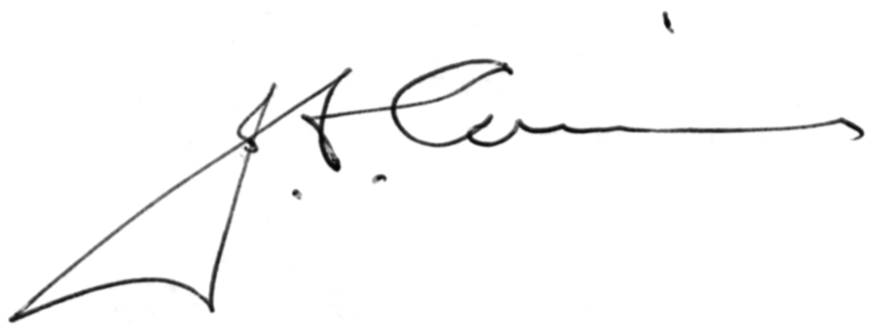

John Cairns MD, FRCPC, FACHS
President-elect and Fellowship Committee Chair
Canadian Academy of Health Sciences

