

e-Newsletter
Visit us on the web at www.cahs-acss.ca
HEALTH MATTERS Volume 2; Issue 7; October 2014  Welcome to the CAHS e-Newsletter, your source for updates on activities of the Canadian Academy of Health Sciences.  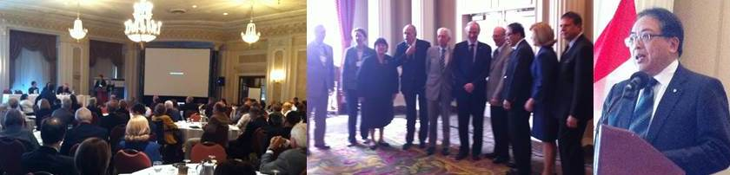  Left: The Annual Forum gets underway. Centre (L-R): Tom Marrie, Alison Buchan, Carol Herbert, Aubie Angel, Paul Armstrong, Cy Frank, John Cairns, Lap-Chee Tsui, Catharine Whiteside, Alain Beaudet. Right: Professor Lap-Chee Tsui, President and Vice Chancellor, University of Hong Kong – the 2014 Recipient of the Henry G Friesen International Prize in Health Research - gave a lunchtime address to CAHS Fellows entitled A Formula for Success – Right Time, Right Place, Right People.  PRESIDENT’S MESSAGE  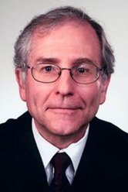  The 2014 Annual meeting was a great success. Registration was at an all-time high, and the energy of the Forum on the Commercialization of Health Research permeated the entire 2-day meeting. The stimulating, challenging tone for the day was set by Peter Nicholson in his opening comments. Subsequent sessions focused on implications of commercialization for academics, funders and health research organizations; lessons learned from Canadian experiences; and considerations for future directions. These were followed by breakout sessions allowing Fellows and guests to reflect and report back from health care provider, primary care and health system perspectives on commercialization. Rick Riopelle and Cy Frank, the co-chairs, did a wonderful job of creating and managing a remarkable day.  The buzz continued through a convivial reception and dinner, during which we inducted 36 of our 50 new Fellows for 2014. Friday morning was given over to scientific sessions: talks by Jane Green of Memorial University, Bartha Knoppers of McGill University and Peter Singer of University of Toronto, who received the Paul Armstrong Lectureship. The final session of the morning was the Annual General Meeting, during which required business of the Academy was transacted, and summaries of our two most recent assessments were presented. Jeff Turnbull (University of Ottawa) and Sioban Nelson (University of Toronto) outlined key aspects of Optimizing Scopes of Practice: New Models of Care for a New Health Care System, which had been released this spring. Paul Allison (McGill University) gave a similar presentation from the just released – Improving Access to Oral Health Care: For Vulnerable People Living in Canada.  I wish to reiterate some of the comments I made at the annual meeting, to you as Fellows of the CAHS. I urge you to engage with the CAHS. Commit to regular attendance at the Annual Meeting and Forum. Realize the potential of your Fellowship to improve the health of Canadians. Take the initiative to conceptualize and propose topics for major assessments – and follow through by using your leadership networks to help CAHS to garner the sponsorship required to undertake a major assessment, and by volunteering to serve on an expert panel. Help to organize a regional meeting of CAHS fellows.  Help the CAHS leadership to define opportunities for the conduct of CCCs – Cast in a Canadian Context – and volunteer to participate in the hard work of actually doing one. Be on the lookout for opportunities for CAHS to host or serve as the honest broker for debates about important and often controversial topics of importance to the health of Canadians.  Use your networks and stature to gain recognition and support for CAHS by the federal and provincial governments. Political clout has helped to create the stature enjoyed by the IOM. Activate your CAHS Fellowship. Ensure that the FCAHS following your name has real meaning.  Sincerely,  John Cairns MD, FRCPC, FRCP (Lond), FCAHS, FACC  SPOTLIGHT – BOARD UPDATES  Report from the Fellowship Committee  After a very successful nomination cycle, the 2014 Fellowship Committee reviewed the process for nominations and adjudication carefully and adopted a few changes that we hope will make the process clearer for nominators and nominees. These will be reflected in the nomination request letter and form that will be sent out in January. The Committee encourages Fellows to nominate directly those individuals whom they feel have outstanding career achievements by the usual measures of scientific success, but who also have demonstrated leadership, creativity, and mastery of special areas that will enhance the capacity of the Academy, and who are committed to advance health sciences beyond their individual research unit. Letters of support may be sought from regional, national, or international sources, as well as from the Dean or Director of the Faculty or Research Institute where the nominee is located. We seek nominations from across the range of health and social sciences.  Standing Committee for Annual Meeting Planning  The Board has established a new Standing Committee for Annual Meeting Planning Committee (SCAMP) to provide continuity to Forum planning.  Committee membership: Chair – President-elect in their second year and first year as President (2 year term); President (2 year term, chairing Committee in the first year); Past President (two year term); Two Fellows (3 year term, renewable once) - to be appointed by the Board from nominations received in response to a call for nominations; Chair or co-chairs of the Forum being planned for September of the following year (1 year term).  Responsibilities: To plan the annual two-day meeting, including the Forum and the AGM; To solicit recommendations for Forum topics and select a topic for the following year by May 1 of the current year; and To select the Chair/co-Chairs of the Forum. The Past President will be responsible for nominating the Paul Armstrong Lecturer and science speakers for the AGM for approval by the SCAMP. Forum Chair/co-Chairs will be responsible for planning the Forum agenda. They may choose to work with one or two Fellows with expertise in the topic area whom they will select. Forum agenda will be approved by the SCAMP, with final approval by the CAHS Board.  Call for nominations for SCAMP Fellow members: At the 2014 AGM, Carol Herbert called for nominations and self-nominations from the membership of CAHS to the Board who will then select two Fellows for staggered three year terms (initially one Fellow will be appointed for a 2 year term in order to ensure both Fellows do not leave the Committee in the same year). She has received a few recommendations, and would ask for any additional nominations to be sent to her at Carol.Herbert@schulich.uwo.ca so that appointments can be made as soon as possible.  Standing Committee on Government Relations  The Board also established a new Standing Committee on Government Relations.  Responsibilities:  - To develop policies to guide Fellows representing CAHS in their interactions with government,  - To develop an approval mechanism for those approaching governments on behalf of CAHS,  - To track Fellows’ interactions with government(s) on behalf of CAHS,  - To arrange annual meetings for CAHS president with Deputy Ministers of Health, Industry Canada, State (Science and Technology),  - To provide newsletters and assessment reports to Deputy Ministers of Health, Industry Canada, State [Science and Technology],  - To facilitate provincial interactions for CAHS Fellows and foster relationships with provincial research foundations and funding agencies.  Call for nominations for Government Relations Committee Fellow members: At or prior to the annual general meeting there will be a call for nominations and self-nominations from the membership of CAHS. The Board will then select three Fellows for staggered three-year terms. Initially one Fellow will be appointed for a two-year term. The committee will be chaired by the Past-President. The President is an ex officio member. If you would like to serve on this committee please send your cv and expression of interest to Tom Marrie t.marrie@dal.ca  Website Update  In keeping with its limited resources during the inaugural years, CAHS has not yet found a good mechanism through which to develop its bilingual web presence. Its priorities for language access have been the assessments, and more recently the newsletters and e-flashes. The Board is now signaling an intention to tackle the website challenge, so that our information is more widely accessible, with materials not simply translated, but also reflective of the nuances and sensibilities of our Francophone community. If there are Fellows particularly interested in being part of this initiative, we’d love to hear from you!  Annual Meeting and Forum  Forum on Commercialization of Research for Health, Social and Economic Benefit: Towards an Evidence-Informed Approach, Sept 18-19, 2014, Ottawa  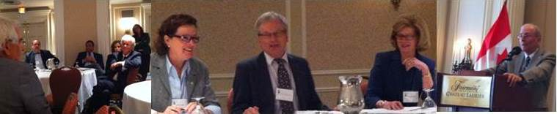  Left: Breakout group discussion. Centre (L-R): Bartha Knoppers, Remi Quirion; Catharine Whiteside. Right: John Cairns  Feature Interview  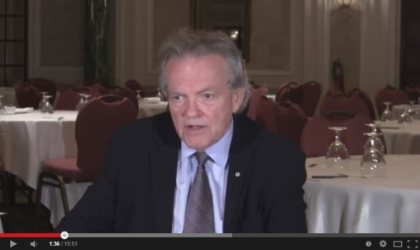  On behalf of the CAHS Communications Committee, Carolyn Gotay personally interviewed Peter Nicholson prior to the Forum. Follow this link and watch the video…  Peter Nicholson discusses his insights on Commercialization/Innovation in Canadian Health Research.  The 2014 CAHS Forum topic brought together a distinguished group of speakers and moderators that fully engaged an enthusiastic audience of Fellows and guests. While the themes addressed throughout the Forum proceedings highlighted the complexities and current shortcomings within the topic at hand, a number of potential directions highlighted by existing exemplars emerged that, taken together with Canada’s strengths (obvious and less obvious), merit future exploration.  Setting the stage for the day, Peter Nicholson’s keynote address highlighted Canada’s academic research excellence as a necessary, but not sufficient, ingredient for innovation (including for-profit at not-for-profit commercialization) directed to the stated benefits. He clearly articulated the challenge for Canada and provided a convincing argument with respect to Canada’s opportunity for both improvement and potential leadership.  Speakers in the moderated plenary sessions rose to the occasion, which became a refrain that was also echoed in the breakout sessions, to state the case for sufficiency on the foundation of academic excellence – the need for academia, Faculties of Health and Life Sciences, academic health organizations, researchers, providers, trainees, industry, and governments all targeting fully engaged end-users (patients, families, and populations) they serve to commit to genuine collaboration within innovation ecosystems. The case for future exploration requires the push of academic excellence, and the pull of health system demand, within an innovation ecosystem approach that involves all partners. The importance of “public-as-partner” in this value proposition cannot be overemphasized.  CAHS owes a huge vote of thanks to Rick Riopelle and Cy Frank for having organized such a vibrant, dynamic and engaging lineup of speakers and discussion sessions. The insights participants took away from this Forum will undoubtedly shape future directions as Canadian health scientists begin to take more seriously the business of putting our marvelous scientific innovations to use.  Induction of New Fellows  A highlight of the annual gathering is always the induction of new Fellows. CAHS was pleased to welcome 50 new Fellows this year, 36 of whom were formerly inducted at the dinner event at the Chateau Laurier. They were promptly treated to a crack of dawn orientation into the Academy the following morning!  Armstrong Lecture  Peter Singer, University of Toronto, CEO of Grand Challenges Canada and Foreign Secretary of the CAHS, was this year’s Paul Armstrong Lecturer. The Armstrong Lecture recognizes leadership and innovation and celebrates extraordinary achievements. Peter’s accounts of the origins and evolution of Grand Challenges indeed met that bill. Peter inspired the audience with his remarkable examples of innovation and implementation in addressing critical barriers to the solution of some of the world’s most important and pressing health problems. Beyond being astounded by the creativity and ingenuity of the projects Grand Challenges Canada sponsors, the Fellows present were truly moved by his passion and commitment to the quality of lives lived across the world. An excellent choice for what the Armstrong Lecture stands for!  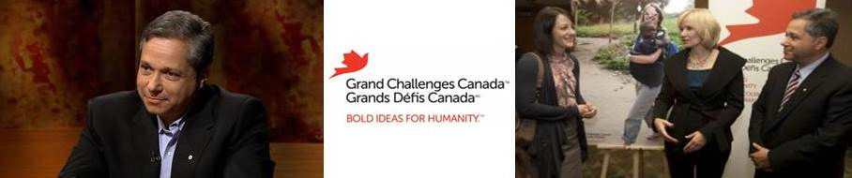  Left: Peter Singer. Right: Karlee Silver, VP, Targeted Challenges for Grand Challenges Canada, Laureen Harper, Honourary chairperson of Grand Challenges Canada's Saving Brains initiative, and Peter Singer.  Suggestions for Future Armstrong Lectures? You may have ideas and recommendations for future Armstrong Lecturers. The Board is always interested in your thoughts on which of our many brilliant members might best represent this ideal in future years. Feel free to send suggestions to Tom Marrie tmarrie@dal.ca or John Cairns john.cairns@ubc.ca  Showcasing Member Research  A highlight of the annual meeting for many is the chance for a brief synopsis of the research of a selection of our members. This year, Jane Green from Memorial University and Bartha Knoppers from McGill University were the featured presenters, and both were not only enlightening but also highly entertaining. Jane described a career in genetics research conducted in the distinctive human environments of Newfoundland and Labrador. Interweaving laboratory science with fieldwork in the living rooms of so many rural and remote communities across the province over many years, she has been able to tap a rare and unique body of genetic understanding that has informed the field more generally. Bartha similarly inspired the audience with her remarkable global influence on genomics science, and her adventures in tackling the ethical and scientific implications at a policy level for this evolving field of inquiry.  Elections  Kim Raines was elected to the Board for a two-year term as Treasurer. Dina Brooks and Linda Rabeneck were elected for three year terms as Discipline Directors for Rehabilitation Sciences and Medicine respectively. Jane Green was elected for a two year term as Director at Large. John Meddings was nominated from the Floor and elected for a term of one year.  The Academy also expressed its sincere gratitude for the service of several Fellows who stepped down this year after completing terms on the Board of Directors: Janice Eng, Cy Frank, David Goltzman, and Jay Kalra. Particularly acknowledged were Jay’s leadership of the complex transition of our fiscal year and other budgetary matters during his term on the Academy Executive as Treasurer; Cy’s leadership of two assessments and co-chairing of the 2014 Forum; David’s chairing of an assessment on Vitamin D and Calcium; and Janice’s strong representation of rehabilitation sciences.  STRATEGIC DIRECTIONS  2015 Forum: The Dementia Challenge  The Board has set the topic for the 2015 CAHS Forum, to be held September 17th in Ottawa. With WHO’s recent declaration of dementia as a public health priority, there is increasing recognition that it is a global disease, with a rapidly increasing prevalence and a staggering impact. Although most industrialized countries have a national dementia strategy, Canada does not. Such a strategy would not only include accelerated and vigorous efforts in neuroscience and clinical trials, but also a coordinated approach involving technology, health care, long term services and supports, public health, housing and community services, and work within the justice and legal domains. Ultimately, coordinated cooperation among science, policy and political constituencies will be required to manage this public health priority in Canada.  The 2015 Forum on the Dementia Challenge will allow CAHS to consider the opportunity and challenges associated with establishing a national strategy, but also to elaborate on the broad societal implications of dementia for Canada, including its epidemiology, demographic patterns, direct and indirect costs, community challenges, and opportunities for intervention across the full trajectory of dementia from onset to death. Carol Estabrooks and Howard Feldman have agreed to coordinate a full slate of topics and speakers toward what will undoubtedly constitute one of CAHS’s most strategic and dynamic events.  Assessment NEWS  Standing Committee on Assessment Update  Jean Gray, Chair, reported to the Board on the results of a recent survey and face-to face meeting with a majority of the past assessment panel chairs and co-chairs. Issues identified through these means included the lack of a CAHS infrastructure for conducting assessments and some shortcomings in CAHS institutional memory. These problems have resulted in each chair or set of co-chairs having to create their own infrastructure and process for conducting and disseminating their assessments. As a consequence of this useful feedback, CAHS has now hired a half-time program director, Ms. Anne Gravel, who previously worked as a policy analyst for CARP and who has extensive media connections. Anne began work on September 8 and sat in on the meeting with the previous panel chairs. At present, in consultation with the staff at the Canadian Council of Academies, she is developing a first draft of a defined process for CAHS assessments and will work with future assessment panels to provide both a secretariat and institutional memory.  The SCA has now turned its attention to two submissions for possible future assessments. In future newsletters, more information about these potential assessments will be provided once a clear question has been identified and the nature of the assessment has been approved by the Board.  The two CAHS assessments completed this year included the Scopes of Practice report, co-chaired by Drs. Jeff Turnbull and SiobanNelson, and the Oral Health of Vulnerable Populations report, chaired by Dr. Paul Allison. Both have had successful public launches and considerable media attention.  Oral Health  On September 13th, in Saskatoon at the Saskatchewan Oral Health Conference, the CAHS published its latest assessment Improving access to oral health care for vulnerable people living in Canada. Originally the idea of Jim Lund, former Dean of the Faculty of Dentistry at McGill University, who unfortunately passed away just as this project was initiated, this report addressed an important topic that touches more and more people across Canada. As the report observed, only 5% of dental care in Canada is financed publicly, and approximately 40% of Canadians pay for dental care directly out of their pockets. Increasing proportions of Canadians do not have private or public insurance to help pay for dental care and these are the same people as have the highest levels of oral disease.  As Paul Allison, Chair of the Assessment Panel that prepared the report, pointed out in an Op Ed published in the Globe & Mail (below) -among several other media outlets- these inequalities in oral health and access to oral health care raise questions over dental care’s exclusion from the medical care system in Canada. Paul Allison on why dental care should be included in the public health system  The panel made recommendations calling for the development of standards of restorative and preventive dental care for all people living in Canada should expect to receive, then the piloting of delivery systems and the exploration of funding schemes to begin to address these problems of access to dental care. Dr. Allison and other members of the panel, with members of the dental professions and other health care professions, aim to use the report to promote discussion of the issue and action to address it. The initial media interest and positive reaction to the report has started the process of sensitizing everyone to the issue, but much remains to do across multiple jurisdictions and with respect to many vulnerable groups in Canada. Nevertheless, the hope is that this CAHS report will be a catalyst for change.  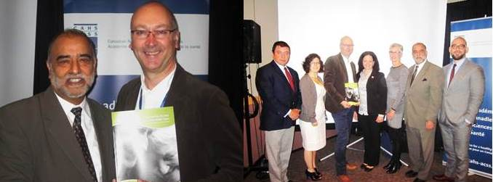  Left: Jay Kalra and Paul Allison. Right (L-R): Dr. Gerry Uswak representing the Association of Canadian Faculties of Dentistry (ACFD); Dr. Alyssa Hayes representing the Canadian Association of Public Health Dentistry (CAPHD); Dr. Paul Allison; Ms. Mary Bertone, President, Canadian Dental Hygienists Association (CDHA); Ms. Janet Gray, member, CAHS assessment panel; Jay Kalra; Dr. Carlos Quinonez, member, CAHS assessment panel.  Scopes of Practice  The assessment on Scopes of Practice, led by Jeff Turnbull and Sioban Nelson, addressed a complex challenge in health system redesign that includes scope of practice for health professionals, appropriate modifications to educational programming, as well as legislative, regulatory and funding frameworks. Building on the 2011 CAHS Forum on The Future of Health Care in Canada, the assessment was launched in 2012 and the final report entitled Optimizing Scopes of Practice: New Models of Care for a New Health Care System was released in 2014. A Summit on Health Professional Scopes of Practice is scheduled this fall to develop an action plan in response to this Assessment.  MEMBER NEWS  Local Meetings  Coordinating a gathering need not involve much by way of time or resources - since getting together with fascinating colleagues is a reward in itself - and we will welcome reports from local meetings in upcoming e-flashes and newsletters. If you are interested in helping build a regional meeting in your area Allison Hardisty in the CAHS Secretariat can support you in contacting local members: a.hardisty@utoronto.ca  Member Updates    On June 30, 2014, the Governor General announced new Order of Canada appointments. CAHS Fellows Harvey Chochinov, Deborah Cook and Cy Frank were among those Canadians named. Their investitures will take place at a future date.    L-R: Harvey Chochinov, Deborah Cook and Cy Frank  In a ceremony held on September 12, 2014 at Rideau Hall, Richard Cruess, Peter Tugwell and Salim Yusef were invested into the Order of Canada.    Sincere congratulations to Judith Hall and Alan Bernstein on their named induction into the Canadian Medical Hall of Fame in 2015.  Jock Murray was inducted into the Canadian Medical Hall of Fame in 2014, and also received The Osler Medal from the American Osler Society.  Greta Cummings was inducted as a Fellow into the American Academy of Nursing in October 2014.  Kenneth Rockwood was named the 2015 recipient of the Dr. Williams B. Abram Award in Geriatric Clinical Pharmacology by the American Society for Clinical Pharmacology and Therapeutics.  An advisory panel on health-care innovation aimed at improving the quality and cost-effectiveness of Canada’s health care system was announced in June by federal Health Minister Rona Ambrose. The panel will be chaired by David Naylor and Cy Frank is one of the appointed panel members.  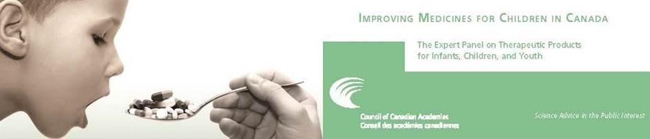  An expert panel chaired by Stuart MacLeod has recently completed an assessment on Improving Medicines for Children in Canada on behalf of the Canadian Council of Academies. CAHS Fellows Terry Klassen and Michael Kramer also served as expert panelists.  Feel free to send your news, including any inadvertently missed major recognitions, to Allison Hardisty at: a.hardisty@utoronto.ca  IMPORTANT DATES  - March 20, 2015: Nominations for next year’s New Fellows  - September 17 & 18, 2015: CAHS Forum and Annual Meeting, Ottawa |  | Secretary’s Note    Those who missed the Forum and AGM in Ottawa may want to pencil in next year’s date now, as you missed a great one. Whether the Forum topic seems directly aligned with your research or not, these sessions are guaranteed to be thought provoking, inspiring, and to push your thinking in new directions. The interaction between Fellows that becomes possible when we gather together is incredible. Treat yourself and plan to join us on September 17 & 18, 2015!  As we build CAHS into the future, I invite you to make this Newsletter your own. Ideas and suggestions for what would facilitate connection always welcome!  Sincerely,  Sally Thorne  Sally.Thorne@ubc.ca  Headlines  Spotlight  Annual Meeting & Forum  Strategic Directions  Assessment News  Member News  Important Dates  Contact  Canadian Academy of  Health Sciences (CAHS)  180 Elgin Street, Suite 1403  Ottawa, Ontario  K2P 2K3  Phone 613-567-2247  Fax 613-567-5060  info@cahs-acss.ca

